Project Planning & Management

1.1 Project Proposal
The Dark Store Location Optimization project provides a data-driven, AI-enhanced GIS solution for identifying the best locations for warehouses. The system evaluates spatial and logistical factors to recommend the optimal location for a dark store.
Objectives:
- Maximize population coverage within targeted service areas.
- Minimize average delivery times by factoring in traffic and road networks.
- Improve overall delivery efficiency and reduce operational costs for Q-commerce startups and logistics providers.
Scope: The scope encompasses the end-to-end development of an AI/GIS project. It begins with acquiring population density data via WorldPop, road network data via OSMnx, and traffic-weighted road network data. The core analytical scope includes Exploratory Spatial Data Analysis (EDA), location-allocation analysis, and the implementation of a genetic algorithm for coordinate optimization.

1.2 Project Plan & Timeline
To meet the academic student deadlines, the project milestones are scheduled as follows:
Milestone 1: Data Collection, Exploration & Preprocessing (Target: Late-April)
  - Acquire and standardize geospatial datasets.
  - Identify competitor locations and existing dark stores.
  - Deliverables: EDA Report, Interactive Visualizations, Cleaned Dataset.
Milestone 2: Exploratory Spatial Analysis (Target: Early May)
  - Visualize population density overlaid with competitor locations.
  - Assess travel-time accessibility and identify underserved clusters.
  - Deliverables: GIS Maps, Spatial Analysis Report.
Milestone 3: AI / ML Modeling (Target: Early June, Implementation phase)
  - Implement classical location-allocation analysis.
  - Enhance optimization using a genetic algorithm.
  - Deliverables: Optimized Location Recommendations, Performance Analysis Report, AI/Optimization Notebook.

Milestone 4: Visualization & Reporting (Target: Early July)
  - Generate travel-time heatmaps and proposed location maps.
  - Document all Python and GIS scripts for reproducibility.
  - Deliverables: Interactive maps/heatmaps, structured reports, and documented scripts.
Milestone 5: Recommendations & Conclusion (Target: 7/17/2026 - Final Presentation)
  - Perform impact analysis on delivery efficiency and coverage improvement.
  - Deliver actionable insights for business decision-makers.
  - Deliverables: Final Project Report, Final Presentation.

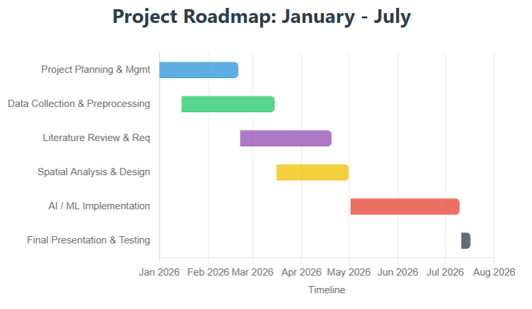

1.3 Task Assignment & Roles (Cross-Functional Agile Model)
To maximize learning and ensure seamless integration, the team operates in a cross-functional structure rather than isolated departments. All tasks, code reviews, and dataset linkages are tracked collaboratively in our ClickUp workspace. Responsibilities are distributed across project milestones using a "Lead and Contributor" format to maintain accountability while sharing the technical workload:

1. Data Engineering & Spatial Preprocessing Pipeline
- Focus: Extracting and standardizing WorldPop, OpenStreetMap (OSMnx), and traffic-weighted road network data, as well as identifying competitor locations.
- Primary Leads: Aya Eslam & Mohamed Tarek.
- Contributors: Yusuf Yasser (advising on data formatting for the AI inputs) and Ram Hany (assisting with data cleaning).

2. Exploratory Spatial Analysis & Feature Engineering
- Focus: Conducting EDA to summarize coverage gaps, mapping population density, and highlighting underserved clusters.
- Primary Leads: Mohamed Tarek & Ram Hany.
- Contributors: Farouk Mohamed (travel-time accessibility checks) and Aya Eslam.
3. AI / ML Modeling & Optimization Engine
- Focus: Implementing the location-allocation model and developing the genetic algorithm for optimal coordinate search.
- Primary Leads: Yusuf Yasser & Farouk Mohamed.
- Contributors: Aya Eslam (feeding derived features like cluster centroids into the model) and Mohamed Tarek (validating outputs against real-world spatial constraints).
4. System Evaluation & Performance Metrics
- Focus: Evaluating candidate locations to minimize travel time, maximize coverage, and generate comparison metrics.
- Primary Leads: Farouk Mohamed & Yusuf Yasser.
- Contributors: Ram Hany (structuring the evaluation data for visualization) and Mohamed Tarek.
5. Visualization, Documentation & Final Delivery
- Focus: Generating interactive travel-time heatmaps, documenting Python/GIS scripts for reproducibility, and compiling the final reports.
- Primary Leads: Ram Hany & Aya Eslam.
- Contributors: All team members are strictly required to document their own code modules and actively participate in the final project presentation.

1.4 Risk Assessment & Mitigation Plan

Identified Risk | Impact | Strategy to overcome
Missing or Inconsistent Geospatial Data | Could severely skew the travel-time analysis and population clusters. | Conduct rigorous EDA early in Milestone 1 to check for missing/duplicate data. Utilize alternative open-source geospatial libraries if primary APIs rate-limit requests.
Algorithm Convergence / High Computational Cost | The genetic algorithm may take too long to find optimal coordinates across large population grids. | Optimize the search space by only evaluating candidate location grids derived from the highest-density underserved clusters.
Scope Creep | Attempting to model too many dynamic variables (e.g., live seasonal demand) too early. | Restrict initial model to static traffic weights and current population data. Log seasonal demand as a "Future Direction" in the final report.

1.5 KPIs (Key Performance Indicators)
To quantitatively measure the success of the optimization engine, we will evaluate candidate locations against the following metrics:
- Average Delivery Time Reduction: Measured in minutes compared to existing competitor benchmarks.
- Population Coverage Percentage: The ratio of the population residing within a highly accessible travel-time radius from the proposed store.
- Competitor Proximity Score: The calculated distance/isolation metric ensuring the proposed location minimizes cannibalization of existing market shares.

